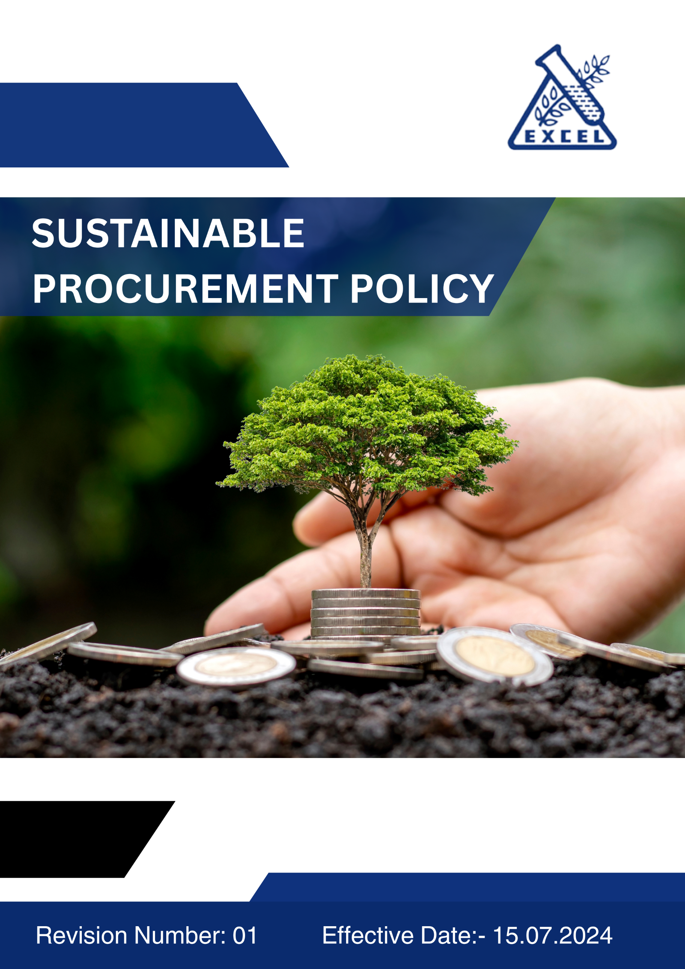
- OBJECTIVES:
Excel Industries Ltd. is committed to integrating Sustainability principles across our supply chain to minimize environmental impacts, ensure responsible social practices, and contribute to ethical business operations. This policy outlines our expectations from suppliers like quality, quantity, cost, timely delivery, logistics and legal compliance with our core sustainability values, ensuring that our procurement practices align with our values and contribute to a sustainable future for the Organization.
- SCOPE:
This policy applies to all activities related to the manufacture, scale-up and supply of industrial chemicals, agrochemical intermediates, specialty chemicals, polymer intermediates, and pharmaceutical products. It also applies to all business units and functions within Excel Industries Limited, including procurement, manufacturing, research and development, logistics and corporate offices. It applies to all workmen working for the company including our own employees, contractors and their workmen working inside the premises, all stakeholders and external providers associated with the company. This policy is applicable across all operating sites of Excel Industries Limited as listed below:
Sr. No. | Site Name | Location / Address
 | Corporate Head Office | 184/87, S.V. Road, Jogeshwari (W), Mumbai, Maharashtra 400102, India.
 | Roha Manufacturing Site | Plot No. 112, 20/1, OS-2, MIDC, Dhatav, Roha, Raigad, Maharashtra 402116, India.
 | Lote Manufacturing Site | D-9, MIDC, Lote Parshuram, Ratnagiri, Maharashtra 415722, India.
 | Visakhapatnam Manufacturing Site | Plot No. 15 & 15A, APSEZ, Atchutapuram, Vishakhapatnam, Andhra Pradesh, 531011, India
 | Excel Bioresources Limited,  Subsidiary | 184/87, S.V. Road, Jogeshwari (W), Mumbai, Maharashtra 400102, India.
 | Kamaljyot Investments Limited,  Subsidiary | 184/87, S.V. Road, Jogeshwari (W), Mumbai, Maharashtra 400102, India
 | Excel Rajkot C&D waste recycling Private Limited, Subsidiary | 184/87, S.V. Road, Jogeshwari (W), Mumbai, Maharashtra 400102, India
- POLICY STATEMENT :
(The Policy statement will be uploaded on website and will be printed for posters, cards etc for the purpose of communication).
Excel Industries Limited, a responsible manufacturer of industrial chemicals, intermediates, specialty chemicals, agrochemical intermediates, and pharmaceutical products, is committed to promoting sustainable procurement practices that foster responsible sourcing, ethical business conduct, and social responsibility throughout our supply chain.
It is the Company’s endeavor to:
- Integrate sustainability principles into all procurement and supply chain decisions.
- Ensure compliance with applicable laws, regulations, and international sustainability standards.
- Source responsibly by engaging with suppliers who uphold ethical, environmental, and social performance standards.
- Promote fair and transparent procurement processes that prevent corruption, bribery, and anti-competitive practices.
- Encourage suppliers to voluntarily, adopt cleaner technologies, renewable energy, waste reduction, and circular economy practices.
- Assess and monitor supplier performance through sustainability audits, feedback, and capacity-building initiatives.
- Foster long-term partnerships with suppliers who share our vision of sustainability, innovation, and continuous improvement.
- Provide training and guidance to procurement teams and suppliers to enhance awareness of sustainable procurement principles.
- Continually review objectives and set measurable targets to improve our sustainable procurement performance.
- Engage stakeholders and customers transparently on our supply chain sustainability performance and progress.
This Sustainable Procurement Policy serves as a guiding framework for responsible sourcing and supplier engagement at Excel Industries Limited, ensuring that sustainability is embedded across our entire value chain.
The policy will be reviewed in every six months in MRM for its adequacy and continuing relevance to the organization’s business. It will be made available to all employees, suppliers, customers, and other stakeholders wherever required.
- QUALITATIVE TARGETS:
The Top Management of the company is committed to provide all organizational support for for achieving qualitative sustainability targets, through the following directives:
Supplier Environmental Practices: We require suppliers to adopt environmentally responsible practices, including but not limited to,
- Energy & GHGs: Suppliers should voluntarily adopt energy-efficient processes and reduce greenhouse gas emissions through renewable energy, energy conservation, and emission control strategies.
- Materials & Waste: Efficient use of raw materials is essential. Suppliers must minimize waste generation, encourage recycling and reusing materials, and responsibly manage hazardous and non-hazardous waste.
- Water Usage: Suppliers should actively monitor and reduce water consumption, ensuring that wastewater is treated and discharged according to environmental regulations.
- Air Pollution: Processes must be designed to minimize emissions and ensure compliance with local air quality standards.
- Chemicals Management: Suppliers are expected to safely handle, store, and dispose of chemicals in compliance with local and international safety and environmental guidelines.
- Biodiversity: Suppliers should avoid sourcing from environmentally sensitive areas and protect ecosystems by promoting biodiversity conservation.

Supplier Social Practices: Excel Industries Ltd. prioritizes fair labor practices and human rights across the supply chain. We expect suppliers to comply with,
- Health & Safety: Maintain safe working conditions by following occupational health and safety regulations, ensuring the well-being of all employees involved in production and supply processes.
- Working Conditions: Adhere to fair labor practices, ensuring workers' rights to fair wages, reasonable working hours, and non-discriminatory work environments.
- Child Labor & Forced Labor: Suppliers must comply with laws prohibiting child labor, forced labor, and human trafficking.
- Diversity, Equity & Inclusion: Excel Industries expects suppliers to foster inclusive work environments that promote diversity and equal opportunity.
- Career Management & Training: Suppliers are encouraged to offer training and career development opportunities to improve employee skills and job satisfaction.

Supplier Ethics & Governance: Suppliers are required to maintain ethical business conduct by,
- Corruption Prevention: Implementing anti-corruption measures to prevent bribery and unethical business dealings.
- Responsible Information Management: Ensuring the protection of confidential data, intellectual property, and sensitive business information throughout the supply chain.

Commitment to Health, Safety, and Sustainability: Excel Industries Ltd. is committed to working with,
- Suppliers who demonstrate leadership in health and safety, environmental responsibility, and social sustainability.
- Comply with local, national, and international regulations related to health, safety, and environmental protection.
- Implement continuous improvement strategies for Sustainability.

- Quantitative TARGETS:
We have set baseline year FY 2021-22 for the below Sustainable Procurement KPIs:

General Targets:
- Ensure 100% of strategic suppliers sign and comply with Excel’s Supplier Code of Conduct by 2034-35.
- Conduct annual supplier ESG self-assessments covering 100% of Tier-1 suppliers by 2034-35.
- Conduct on-site ESG audits for 100% of our high-risk suppliers every year, effective by 2034-35.
- Ensure 100% of procurement employees and key suppliers receive ESG training annually by 2034-35.
- Achieve zero incidents of major supplier non-compliance with sustainability or ethical requirements by 2034-35.

Supplier Environmental Practices
- Energy & GHGs: Reduce total supply chain Scope 3 GHG emissions by 15% by 2034-35 compared to 2021 baseline.
- Water: Achieve 10% reduction in supplier water consumption and ensure 100% wastewater treatment compliance by 2034-35.
- Waste: Reduce waste generation by 10% and achieve 20% recycling/reuse rate across supplier operations by 2034-35.
- Materials: Ensure 25% of raw material procurement comes from sustainable or recycled sources by 2034-35.
- Air Emissions: Ensure 100% of key suppliers comply with local and national air quality regulations by 2034-35.

Supplier Social Practices
- Ensure 100% supplier compliance with fair labor, human rights, and non-discrimination laws by 2034-35.
- Maintain zero (0) incidents of child labor or forced labor in the supply chain by 2034-35.
- Ensure 100% of supplier workplaces provide safe and healthy working conditions by 2034-35.
- Increase female participation in supplier workforce by 10% across key supplier facilities by 2034-35.

Supplier Ethics & Governance
- Achieve zero (0) incidents of corruption, bribery, or anti-competitive practices across the supply chain by 2034-35.
- Conduct due-diligence assessments for 100% of new suppliers before onboarding by 2034-35.
- Maintain 100% data protection compliance among all suppliers handling confidential or sensitive information by 2034-35.
- Integrate ethical performance metrics into supplier evaluation and renewal processes by 2034-35.

Commitment to Health, Safety, and Sustainability
- Ensure 100% of suppliers comply with occupational health and safety regulations by 2034-35.
- Achieve zero (0) fatalities or major work-related injuries across supplier operations by 2034-35.
- Ensure 100% supplier compliance with Excel’s sustainability and EHS improvement initiatives by 2034-35.

- Monitoring and Evaluation :
- Excel Industries will regularly assess supplier performance through visits, audits, reviews, and other suitable feedback mechanisms.
- Suppliers will be evaluated on their ability to meet or exceed environmental, social, and ethical standards.
- Non-compliances will be reviewed accordingly; it may result in corrective actions or termination of business relationships.
- Governance and Responsibilities:
- Managing Director and President & COO: Oversight of Sustainable Procurement Policy and Performance.
- Vice President Operations: Development and implementation of Procurement strategies.
- Management Review Meeting (MRM) committee: Responsible for monthly review of the Policy at all sites to assess progress and make necessary amendments as required. Evaluates Procurement performance metrics and KPIs. Ensures cross-functional coordination on Procurement initiatives.
- Procurement Department: Responsible for the day-to-day management of supplier relationships, ensuring adherence to the Sustainable Procurement Policy, and integrating sustainability criteria into procurement processes.
- Functional Heads: Responsible for integrating SPP and practices within their units.
- Department Heads: Ensure that their respective departments comply with sustainable procurement policies and report progress and issues to the Procurement Department.
- All Employees Involved in Procurement: Adhere to the Sustainable Procurement Policy, ensure compliance in supplier selection, and report any concerns or violations.
- Implementation and Accountability:
- Compliance: Ensure compliance with all relevant Procurement laws, regulations and National / International Standards.
- Training: Provide regular training for employees on Sustainable Procurement Policy, Practices, and Responsibilities.
- Performance Monitoring: Set measurable Sustainable Procurement performance goals and regularly review progress towards achieving these goals.
- Transparency: Report our Sustainable Procurement performance and progress in a transparent manner to stakeholders.
- Policy Review Mechanism:
- Excel Industries will regularly assess supplier performance through audits, reviews, and other suitable feedback mechanisms. Suppliers will be evaluated on their ability to meet or better environmental, social and ethical standards.
- Monthly Review: The Policy will be reviewed monthly at all the sites during Management Review Meeting (MRM) committee to assess progress and make necessary amendments, if required.
- SCM department will be evaluated through assessment towards completion of qualitative objectives and quantitative targets and identifying areas for improvement in supplier environmental and social practices.
- Performance Reporting: Regular reporting on environmental performance to the MRM Committee happens on a six monthly basis. The Board of Directors and stakeholders review environmental performance reporting through the Business Responsibility and Sustainability Report (BRSR) and Annual Sustainability Report (ASR) on a yearly basis.
- Stakeholder Engagement: Continuous dialogue with stakeholders to incorporate feedback and improve our Sustainable Procurement practices.
- Non-compliance may result in corrective actions or termination of business relationships.
- Failure of COMPLIANCE:
Employees who find any violation of the Sustainable Procurement Policy or its processes or its activity which may cause direct or indirect harm to the business sustainability should address the same to the HOD and further escalate to SCM Head at site or at Head Office.
Failure to comply with the provisions of this policy will be considered as violation of policy and will be subject to disciplinary action.
- Conclusion:
Excel Industries Limited is committed to leading by example in promoting sustainable and ethical procurement practices across its entire value chain.
Through the effective implementation of this Sustainable Procurement Policy, we aim to ensure responsible sourcing, foster supplier partnerships built on trust and transparency, and continually enhance our environmental and social performance.

This policy will be reviewed Monthly to ensure its continued suitability to the organization’s business objectives and evolving sustainability standards.

We will make this policy accessible to all employees, suppliers, customers, and stakeholders to demonstrate our unwavering commitment to sustainable growth and ethical excellence.
- POLICY DISTRIBUTION RECORD:
Sr. | Department | No. of copies
1 | All Departments: Mumbai Office. | ~10
2 | All Departments: Roha Site. | ~12
3 | All Departments: Lote Site. | ~12
4 | All Departments: Visakhapatnam Site. | ~10
NOTE: The Master Copy of this Policy document bears original signatures and a “MASTER COPY” stamp on each page, all controlled copies of this Policy are photocopies of the signed master copy, with a “CONTROLLED COPY” stamp. All other unsigned copies, printed copies, photocopies, or electronic copies of this Policy are uncontrolled copies.
- ACCOUNTABILITY (Document Preparation):
This policy will be prepared by Manager SCM, Checked by GM Sustainability, reviewed by VP SCM and President & COO. The policy will be approved and signed by the Managing Director of the company.
- REVISION HISTORY:
VERSION  NO. | DATE OF REVIEW | REASON FOR REVISION  (if revised). | APPROVED BY
00 | 15.07.2024 | New Document | R.A.Shroff
01 | 01.08.2025 | Added Employee Acknowledgement section and modified Quantitative Targets | R.A.Shroff

- EMPLOYEE ACKNOWLEDGEMENT:
I, the undersigned, acknowledge that I have read, understood, and agree to comply with the Sustainable Procurement Policy of Excel Industries Limited.
I am aware that this policy outlines the organization’s commitment to promoting responsible sourcing, ethical governance, supplier engagement, and environmental and social responsibility across the value chain.

I understand my individual responsibility to:
- Follow all sustainable procurement and ethical sourcing guidelines described in this policy.
- Support supplier development initiatives that promote sustainability and transparency.
- Report any non-compliance, unethical behavior, or environmental and social violations to my supervisor or the SCM Department.
- Participate in required training and awareness sessions on sustainable procurement.
- Contribute toward achieving the company’s sustainability objectives and supplier performance goals.

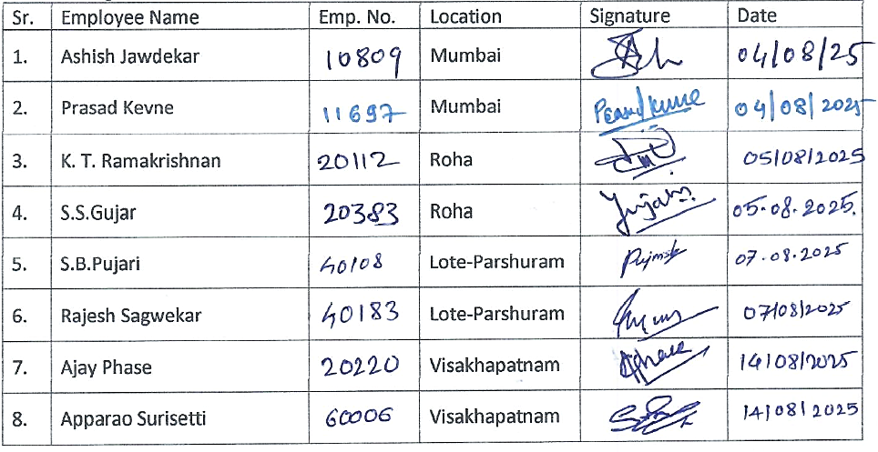
I also understand that failure to comply with this policy may result in disciplinary action as per company rules and regulations

